Experiment :3 Date:

BREADTH FIRST SEARCH & DEPTH FIRST ALGORITHM

AIM: To implement the Breadth First Search (BFS) and Depth First Search (DFS) algorithms for traversing a graph.

Theory:

BREADTH FIRST SEARCH (BFS)
Breadth First Search (BFS) is an uninformed search and graph traversal algorithm used to systematically explore the nodes of a graph or state-space tree. It begins from a specified initial node and explores all nodes at the current depth before moving to nodes at the next depth level.

BFS uses a Queue data structure to maintain the order in which nodes are explored. A queue follows the FIFO (First In, First Out) principle. Therefore, the node that is discovered first is explored first. This ensures that nodes are explored according to their distance from the starting node.

ALGORITHM:

- Start with the given graph and select the starting vertex.
- Create an empty queue.
- Create a visited set/array to keep track of visited vertices.
- Mark the starting vertex as visited.
- Insert the starting vertex into the queue.
- Repeat until the queue becomes empty:
  - Remove the front vertex from the queue.
  - Visit and display the vertex.
  - Find all adjacent vertices of the current vertex.
  - For each adjacent vertex:
    - If it has not been visited, mark it as visited.
    - Add it to the queue.
- Continue the process until the queue becomes empty.
- Stop.

Example
Consider the following graph:
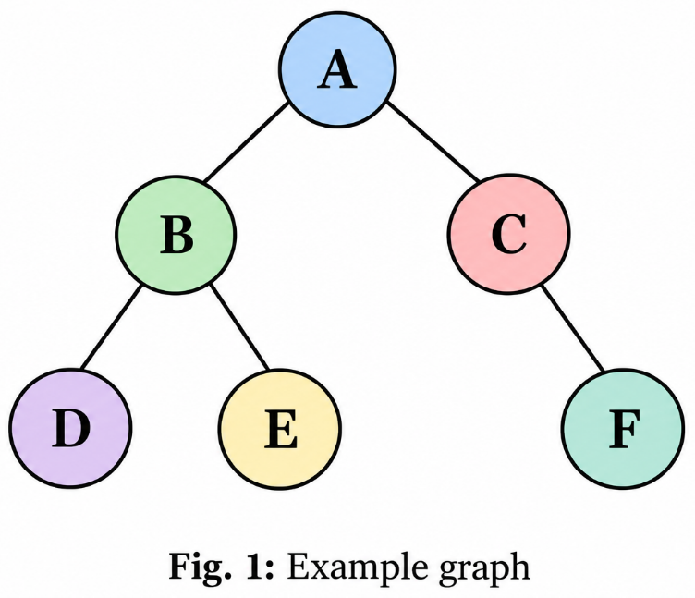

Starting from node A, BFS explores the graph level by level:
- Level 0: A
- Level 1: B, C
- Level 2: D, E, F
Therefore, the BFS traversal is:
A → B → C → D → E → F

DEPTH FIRST SEARCH (DFS)

Depth First Search (DFS) is a graph traversal and uninformed search algorithm that explores a graph by going as deep as possible along one branch before backtracking and exploring another branch.
DFS can be implemented using a Stack data structure or through recursion. A stack follows the LIFO (Last In, First Out) principle.

For the example graph, starting from vertex A, one possible DFS traversal is:
A → B → D → E → C → F
The exact DFS traversal order can vary depending on the order in which adjacent vertices are considered.

DFS Algorithm
- Start with the given graph and select the starting vertex.
- Create a visited set/array.
- Mark the starting vertex as visited.
- Visit and display the starting vertex.
- Explore an unvisited adjacent vertex.
- Mark the adjacent vertex as visited.
- Recursively repeat the process for the newly visited vertex.
- If no unvisited adjacent vertex is available, backtrack to the previous vertex.
- Continue until all reachable vertices have been visited.
- Stop.

Example
Considering the same graph:

- Step 1: Visit A.
- Step 2: Go to B (first child of A).
- Step 3: Go to D (first child of B).
- Step 4: D has no unvisited child, so backtrack to B and go to E (next child of B).
- Step 5: E has no unvisited child, so backtrack to A and go to C (next child of A).
- Step 6: Go to F (child of C).
- Step 7: F has no unvisited child. Backtrack to C and then to A. All nodes have been visited.
Therefore, the DFS traversal is:
A → B → D → E → C → F

CODE:

OUTPUT:

CONCLUSION:

